**sample parts, now in order of size:**

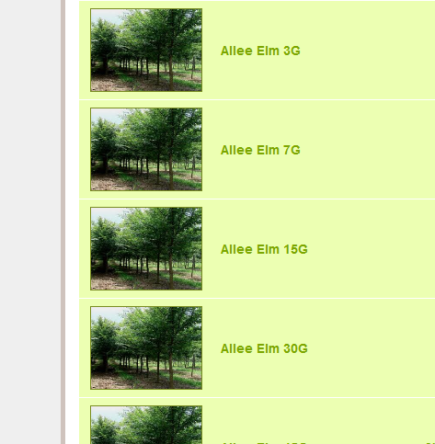

**sample part showing size in description:**

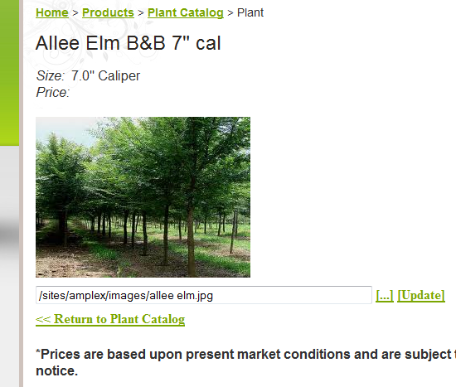

**To edit the sizes:**

login at /admin page (http://aboutamplex.com/admin), choose ‘Website Admin’

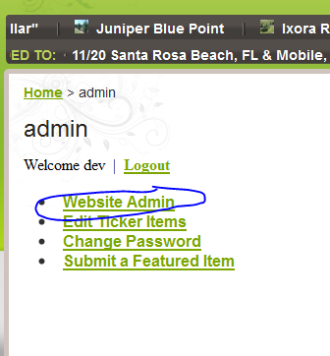

**choose ‘plugins’**

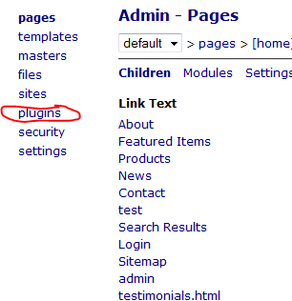

**choose ‘parts’**

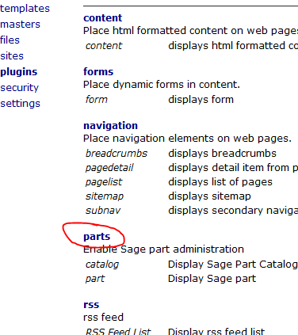

**choose ‘sizes’**

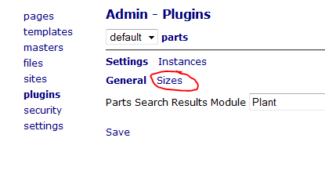

**order the sizes by selecting up / down arrows:**

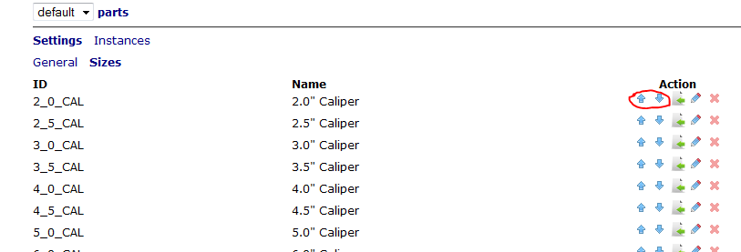

**use edit to change size name**

**use delete to remove size (only enabled if size is not used by any item)**

**use references button to see what parts use this size**

**size name now appears in size page:**

